**Front-End CA3 _READ ME**

**Ana Karolina Silveira Dias 20630**

**🡪 Web-site 2 🡪node_modules 🡪 index.html**

**Project Summary**

For this project ill use bootstrap that I download from the website. I’ll based my website on some ideas from http://www.pascalvangemert.nl , because I thought simple clean and very creative.

**Development Process**

**Starting Off - Initial Ideas**

**Webpages, layout and structure**

* 4 page with the subjects: Main – Resume – Interests - Contact
* Colours –I was planning to follow the pictures colours, yellow, pink, purple or blue.
* Font – To be seen
* Consistent, user-friendly and accessible design.

**Coding the layout and structure**

* I started by coding the navigation bar and the layout. Profile, Experiences, Abilities, Project and Contact.
* I added a carrousel with two pictures from pixabay.
* I added a space where I’m planning to do some animation.
* The navigation bar at mobile and tablet view squashes into a box so users don't have to scroll across to the other links.
* As I’m run out of the time ill put all the topics in just one page with a navSpy.
* I change the pages instead of 5 its now 4:
* The main page where Ill left my cv, and updates.
* Resume, an animated resume
* Interest: funny animated page with my preferences.
* Contact social and email just in case of the person wants to send message me.
* All the information’s included the interests items its going to be chance at the future. The main intention is just keep a space to the future I’ll update.

**Final touches**

* At the end I left my nav bar with my Resume, Interests, Contact, social.
* I need to do some adjustments, like the interests page, the pictures size, the content of my cv.
* Also intent to add a skills bar, preferably animated
* And change the letters and the colours.

**Issues Faced/Solved**

* I had trouble setting up the GitHub repository. So I build it at the brackets because I have more experience in it.
* I had problems to put some animation so I had to open the nav bar that I had delete previously.
* My carrousel it wasn’t working, at the end it was a mistake closing brackets
* I also have problems with the navSpy, but it was the same problem.
* I had issus with my css file so at the end I left some at the page
* I did a joke with the interests but I intent to remove or do it better.
* I also had difficult wit the animation at the main text so I add all the nav bar because of it, and a add a scratch animation.
* All my information’s isn’t update and I use Loren Ipsen and the web page.
* I had difficulties with all pictures sizes.

**Wireframe sketches**

Here are some early sketches I did of the website. These sketches include what the website would look like in every screen size.

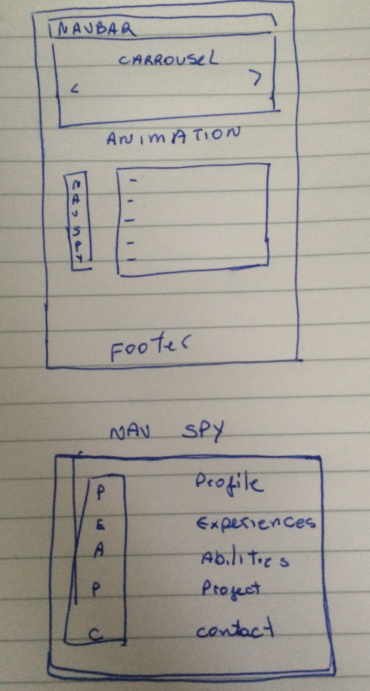

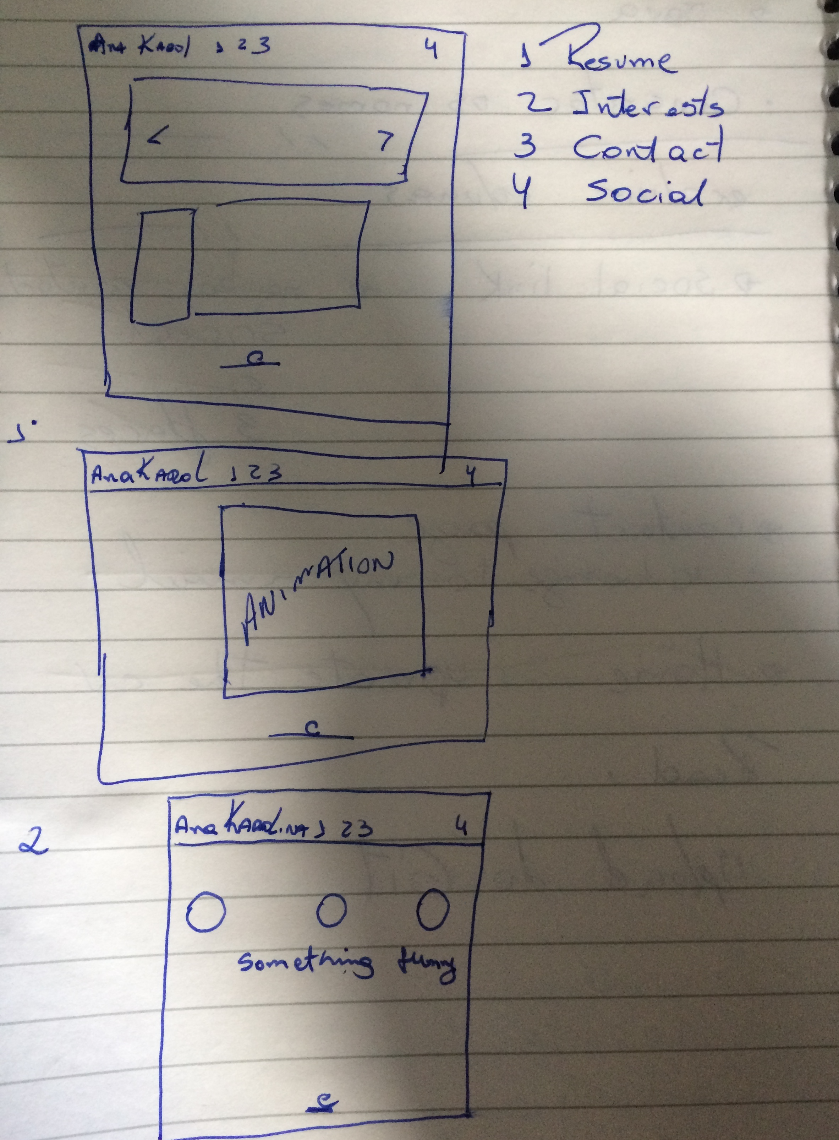

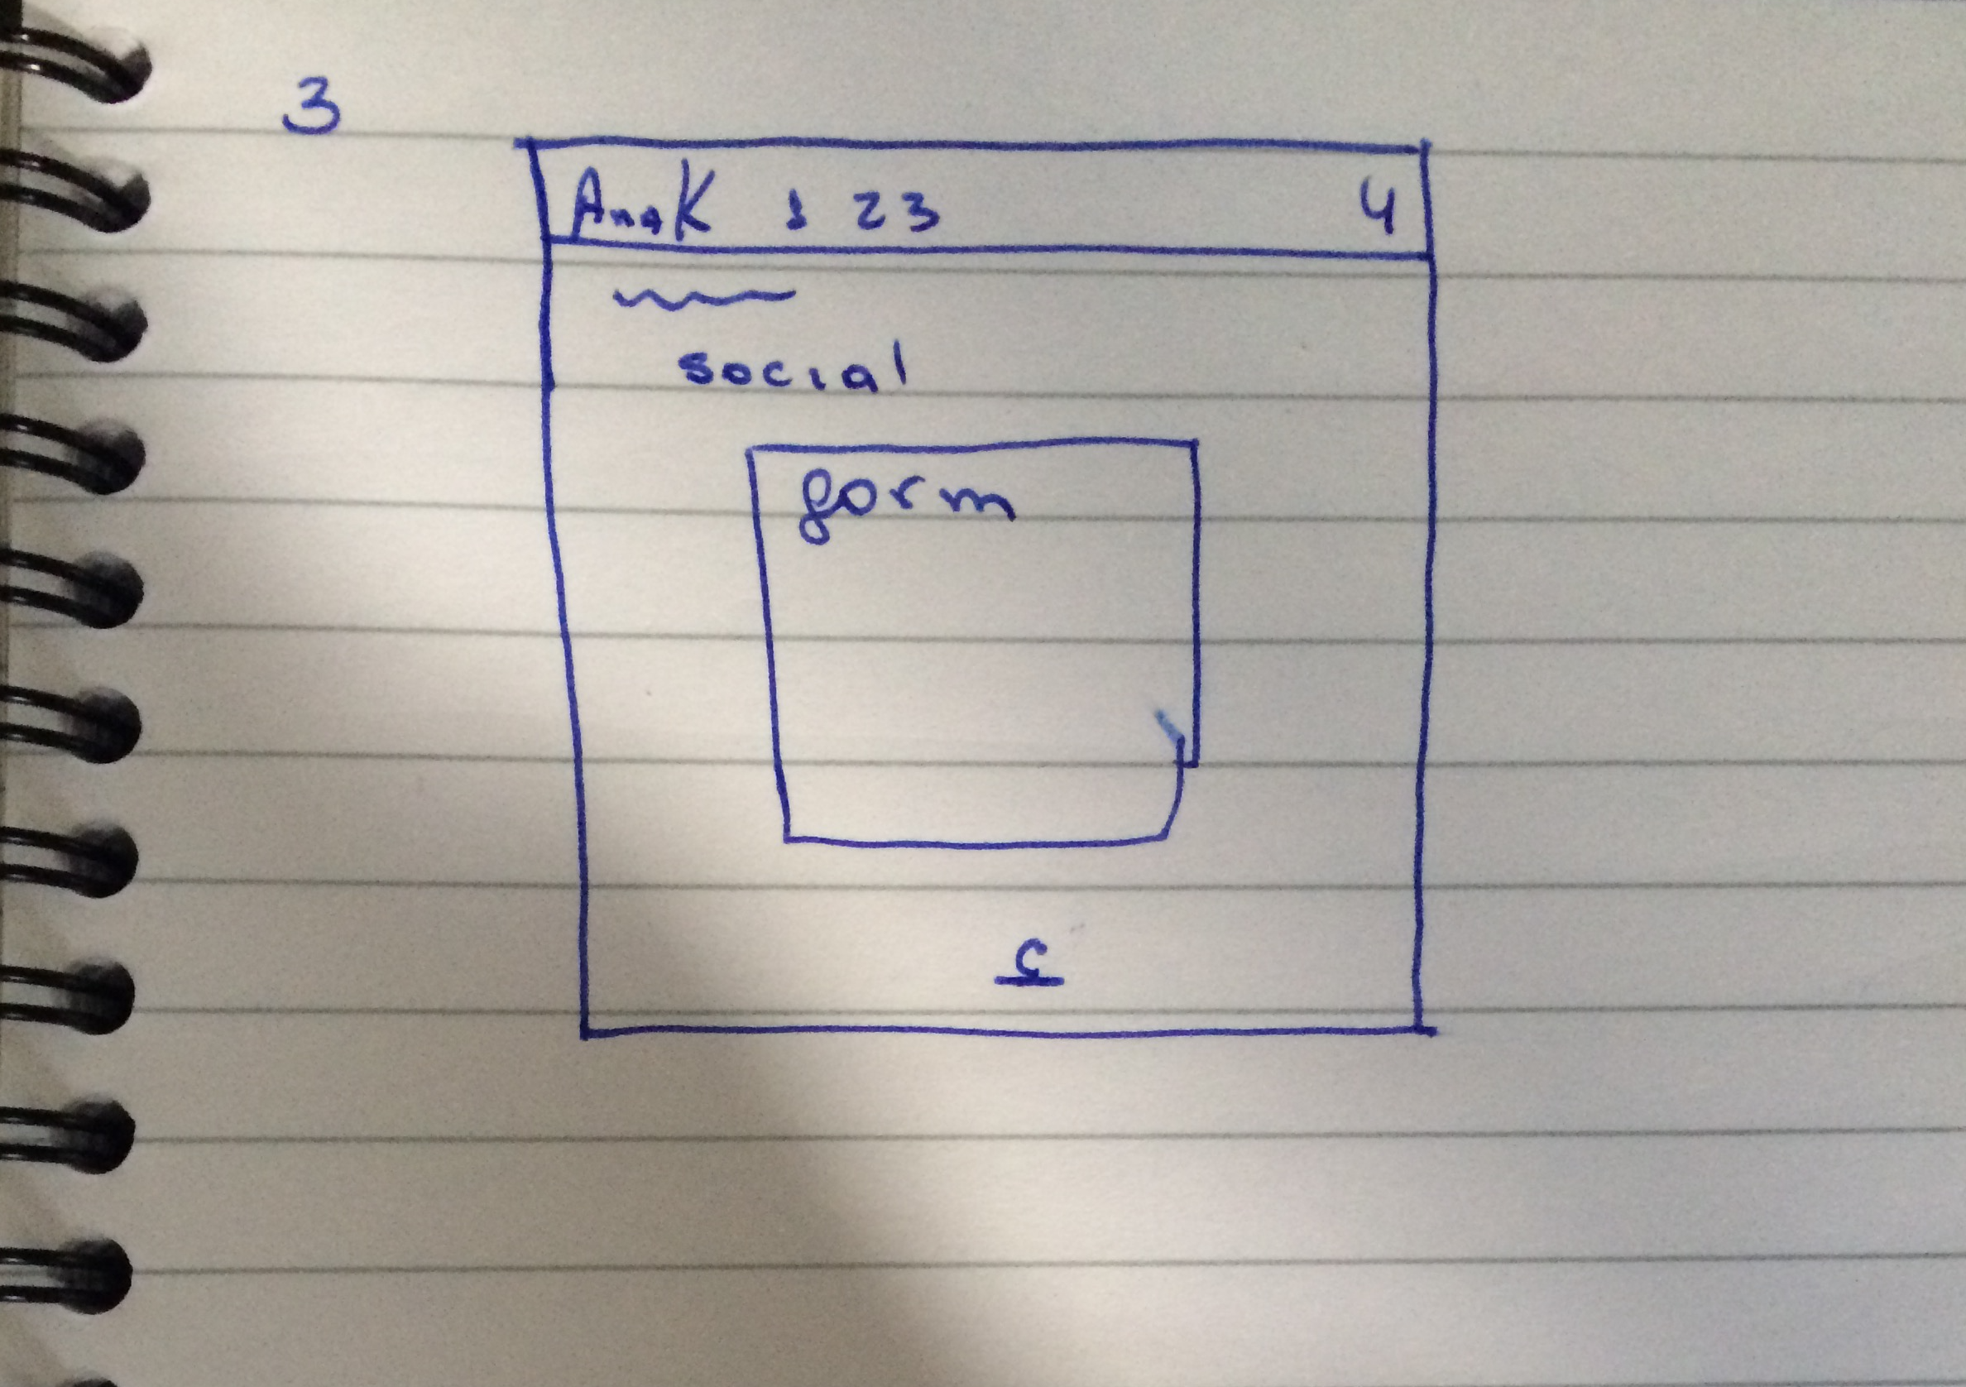

**Link:**

https://github.com/AnaKarolina52/WebCA3.git